**Data Structure Practical 8**

**ROLL NO : MA075**

1. Write a program to implement an undirected graph with the following.

➔ Create an adjacency matrix.

➔ Create an adjacency List.

➔ Print the information of the graph such as number of edges, edges list, degree

of each vertex. (Using both matrix and list)

➔ implement traversal of graph using DFS (using both matrix and list)

➔ implement traversal of graph using BFS. (Using both matrix and list)

**CODE:**

Hello

#include <stdio.h>

#include <stdlib.h>

#define max_vert 50

int ADJMAT[max_vert][max_vert];

typedef struct node

{

int vertex;

struct node *next;

} Node;

Node *adjList[max_vert];

int numVertices = 0, numEdges = 0;

void addEdge(int src, int dest)

{

ADJMAT[src][dest] = 1;

ADJMAT[dest][src] = 1;

Node *newNode = (Node *)malloc(sizeof(Node));

newNode->vertex = dest;

newNode->next = adjList[src];

adjList[src] = newNode;

newNode = (Node *)malloc(sizeof(Node));

newNode->vertex = src;

newNode->next = adjList[dest];

adjList[dest] = newNode;

numEdges++;

}

void dfsMatrix(int vertex, int visited[])

{

visited[vertex] = 1;

printf("%d ", vertex);

for (int i = 0; i < numVertices; i++)

{

if (ADJMAT[vertex][i] && !visited[i])

{

dfsMatrix(i, visited);

}

}

}

void dfsList(int vertex, int visited[])

{

visited[vertex] = 1;

printf("%d ", vertex);

Node *currNode = adjList[vertex];

while (currNode != NULL)

{

int adjVertex = currNode->vertex;

if (!visited[adjVertex])

{

dfsList(adjVertex, visited);

}

currNode = currNode->next;

}

}

void bfsMatrix(int startVertex)

{

int visited[max_vert] = {0};

int queue[max_vert];

int front = -1, rear = -1;

visited[startVertex] = 1;

queue[++rear] = startVertex;

while (front != rear)

{

int vertex = queue[++front];

printf("%d ", vertex);

for (int i = 0; i < numVertices; i++)

{

if (ADJMAT[vertex][i] && !visited[i])

{

visited[i] = 1;

queue[++rear] = i;

}

}

}

}

void bfsList(int startVertex)

{

int visited[max_vert] = {0};

int queue[max_vert];

int front = -1, rear = -1;

visited[startVertex] = 1;

queue[++rear] = startVertex;

while (front != rear)

{

int vertex = queue[++front];

printf("%d ", vertex);

Node *currNode = adjList[vertex];

while (currNode != NULL)

{

int adjVertex = currNode->vertex;

if (!visited[adjVertex])

{

visited[adjVertex] = 1;

queue[++rear] = adjVertex;

}

currNode = currNode->next;

}

}

}

void printGraph()

{

printf("Number of vertices: %d\n", numVertices);

printf("Number of edges: %d\n", numEdges);

printf("Edges list:\n");

for (int i = 0; i < numVertices; i++)

{

Node *currNode = adjList[i];

while (currNode != NULL)

{

if (i < currNode->vertex)

{

printf("%d - %d\n", i, currNode->vertex);

}

currNode = currNode->next;

}

}

printf("Adjacency Matrix:\n ");

for (int i = 0; i < numVertices; i++)

{

printf("%d ", i);

}

printf("\n");

for (int i = 0; i < numVertices; i++)

{

printf("%d: ", i);

for (int j = 0; j < numVertices; j++)

{

printf("%d ", ADJMAT[i][j]);

}

printf("\n");

}

}

void createGraph()

{

numVertices = 7;

for (int i = 0; i < numVertices; i++)

{

adjList[i] = NULL;

}

addEdge(0, 1);

addEdge(0, 3);

addEdge(1, 2);

addEdge(1, 3);

addEdge(2, 4);

addEdge(2, 3);

addEdge(3, 4);

}

int main()

{

createGraph();

printf("Undirected Graph:\n");

printf(" DFS using adjacency matrix:\n");

int visited[max_vert] = {0};

dfsMatrix(1, visited);

printf("\n");

printf("DFS using adjacency list:\n");

int visitedList[max_vert] = {0};

dfsList(1, visitedList);

printf("\n");

printf("BFS using adjacency matrix:\n");

bfsMatrix(1);

printf("\n");

printf("BFS using adjacency list:\n");

bfsList(1);

printf("\n");

printGraph();

return 0;

}

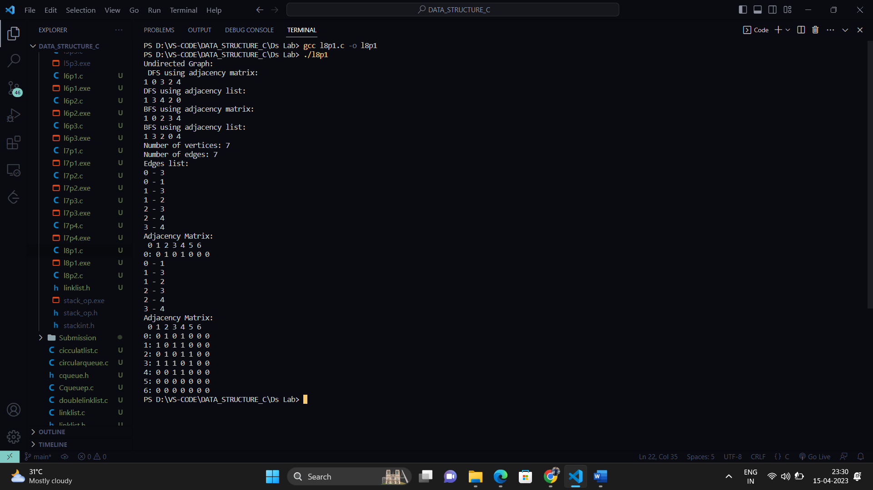

Q-2)

2. Write a program to implement a directed graph with the following.

➔ Create an adjacency matrix.

➔ Create an adjacency List.

➔ Print the information of the graph such as number of edges, edges list,

degree

of each vertex. (using both matrix and list)

➔ implement traversal of graph using DFS (using both matrix and list)

➔ implement traversal of graph using BFS. (using both matrix and list)

#include <stdio.h>

#include <stdlib.h>

#define max_vert 50

int ADJMAT[max_vert][max_vert];

typedef struct node

{

int vertex;

struct node *next;

} Node;

Node *adjList[max_vert];

int numVertices = 0, numEdges = 0;

void addEdge(int src, int dest)

{

ADJMAT[src][dest] = 1;

Node *newNode = (Node *)

malloc(sizeof(Node));

newNode->vertex = dest;

newNode->next = adjList[src];

adjList[src] = newNode;

numEdges++;

}

void dfsMatrix(int vertex, int visited[])

{

visited[vertex] = 1;

printf("%d ", vertex);

for (int i = 0; i < numVertices; i++)

{

if (ADJMAT[vertex][i] && !visited[i])

{

dfsMatrix(i, visited);

}

}

}

void dfsList(int vertex, int visited[])

{

visited[vertex] = 1;

printf("%d ", vertex);

Node *currNode = adjList[vertex];

while (currNode != NULL)

{

int adjVertex = currNode->vertex;

if (!visited[adjVertex])

{

dfsList(adjVertex, visited);

}

currNode = currNode->next;

}

}

void bfsMatrix(int startVertex)

{

int visited[max_vert] = {0};

int queue[max_vert];

int front = -1, rear = -1;

visited[startVertex] = 1;

queue[++rear] = startVertex;

while (front != rear)

{

int vertex = queue[++front];

printf("%d ", vertex);

for (int i = 0; i < numVertices; i++)

{

if (ADJMAT[vertex][i] && !visited[i])

{

visited[i] = 1;

queue[++rear] = i;

}

}

}

}

void bfsList(int startVertex)

{

int visited[max_vert] = {0};

int queue[max_vert];

int front = -1, rear = -1;

visited[startVertex] = 1;

queue[++rear] = startVertex;

while (front != rear)

{

int vertex = queue[++front];

printf("%d ", vertex);

Node *currNode = adjList[vertex];

while (currNode != NULL)

{

int adjVertex = currNode->vertex;

if (!visited[adjVertex])

{

visited[adjVertex] = 1;

queue[++rear] = adjVertex;

}

currNode = currNode->next;

}

}

}

void printGraph()

{

printf("Number of vertices: %d\n",numVertices);

printf("Number of edges: %d\n", numEdges);

printf("Edges list:\n");

for (int i = 0; i < numVertices; i++)

{

Node *currNode = adjList[i];

while (currNode != NULL)

{

printf("%d -> %d\n", i,

currNode->vertex);

currNode = currNode->next;

}

}

printf("Adjacency Matrix:\n ");

for (int i = 0; i < numVertices; i++)

{

printf("%d ", i);

}

printf("\n");

for (int i = 0; i < numVertices; i++)

{

printf("%d: ", i);

for (int j = 0; j < numVertices; j++)

{

printf("%d ", ADJMAT[i][j]);

}

printf("\n");

}

}

void createGraph()

{

numVertices = 7;

for (int i = 0; i < numVertices; i++)

{

adjList[i] = NULL;

}

addEdge(0, 1);

addEdge(0, 3);

addEdge(1, 2);

addEdge(1, 3);

addEdge(2, 4);

addEdge(2, 3);

addEdge(3, 4);

}

int main()

{

createGraph();

printf(" (DFS using adjacency matrix:\n");

int visited[max_vert] = {0};

dfsMatrix(1, visited);

printf("\n");

printf("DFS using adjacency list:\n");

int visitedList[max_vert] = {0};

dfsList(1, visitedList);

printf("\n");

printf("BFS using adjacency matrix:\n");

bfsMatrix(1);

printf("\n");

printf("BFS using adjacency list:\n");

bfsList(1);

printf("\n");

printGraph();

return 0;

}

